Global Ministries | The United Methodist Church
Pacific Island Ministry Plan
Youth Program Grant Application
(Maximum grant award: $5,000)

Please use this application for the Youth Program grant only.
Return this application and all other supportive documents to:
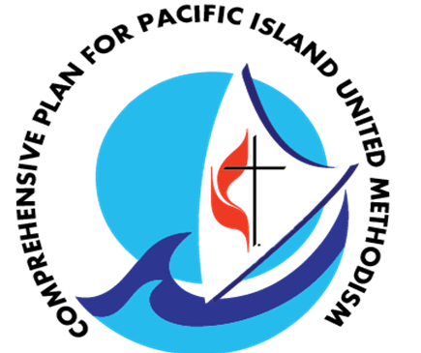
Dana Lyles, PhD
Director of Multiethnic Ministries
dlyles@umcmission.org

http://www.umcmission.org/Connect-with-Us/National-Plans/Pacific-Islander-National-Plan
458 Ponce de Leon Ave NE, Building A, Suite 1, Atlanta, GA 30808
(T): 770-625-7833

Application Guidelines

Introduction

The Pacific Islanders Ministry Plan (PIMP) was established by the General Conference of The United Methodist Church to strengthen the ministries of Pacific Islanders communities. As an entity of The UMC, the Plan seeks to empower Pacific-Island United Methodists to fully participate in the life of The UMC and be agents of Christian love and service within the world community. To that end, the PIM plan has focused on the following priorities in its continued efforts to help Pacific Islanders navigate their faith life in their new setting, while honoring the innate gifts they bring:
- Leadership Development]
- Development of Community/ Outreach Ministry
- Development of Language Resources and Materials
- Global Health

Youth Program Grant Rationale
The Youth Program Grant is an initiative of the PIM Plan to assist Pacific Islander youth groups participate in denomination-sponsored district, conference, and national youth events.

Funding Criteria
- For this special and limited fund, the youth group must attend a denomination-sponsored district, conference or national youth event.
- All grants require a signature from the local pastor in charge and/or appropriate leader, and the current sub-ethnic Caucus Chair, and/or District Superintendent where appropriate.
- The youth group must be located in or sponsored by a local PIM Plan United Methodist Church in the United States. Consistent with the purpose of the PIM Plan to strengthen UM Pacific Island ministry, applications must be from a Pacific Island ministry, i.e., fellowship, congregation, charter church; or from non-PI churches with at least 51% PI members.
- The maximum Youth Program grant amount is $5,000.
- Grant applications shall be accepted from March 1 to April 30, reviewed on a first come first served basis; and administered through an expedited process of the PIM Plan funding review committee. Thereafter, it may be accepted as needed, where appropriate.
- Applicants are encouraged to consult with the PIM Plan Committee or Global Ministries staff for guidance while preparing the application.

Part I: Applicant Information
Project Title
Amount Requested
($5,000 max)
Project Duration
Project Objective | ☐ Leadership Development  ☐ Church Growth  ☐ Ministry with the Poor  ☐ Language Resources and Materials  ☐ Global Health
Implementing Church/ Caucus/ Entity | Name
 | Address
 | Annual Conference
 | Phone
Contact Person | Name
 | Title
 | Phone
 | Email
 | Address- if different than above
Describe the youth ministry you hope to assist with this project.
(25 words or less)

Part II: About Your Project
- Describe your need(s): setting, financial hardship and the desired event, number of youth attending.

- How will attending the event be beneficial for the youth? Which PIM Plan goal and objective does this program grant address (as listed on page 2)?

- How many people in total will benefit from this event? (50 words or less)

- What will be the outcome or result from this grant support? (50 words or less)

- Please list previous funding from PIM Plan or other UMC resources.

- How will the youth ministry continue to be sustained after attending the event? (50 words or less)

BUDGET INFORMATION FOR PROJECT/STAFF POSITION
INCOME: |  | EXPENSES: please be specific about how the fund will be used
Local Church
Other funding sources if applicable:
List each separately

Funds from PIM Plan Grant
Community Organizations
GRAND TOTAL INCOME |  | GRAND TOTAL EXPENSES
*The income shall include a local church contribution of at least 15%.
*The income must equal the expenses.

Review and Signature

My signature below confirms that I have reviewed this application and that I am otherwise knowledgeable about the project and this proposal which will be reviewed by the PIM Plan Funding Review Committee and by the staff of the General Board of Global Ministries.

Pastor in Charge(must include signature if it is a local church project.)

Signature: __________________________________________ Date:_______________
Name: (Print)______________________________________________________________

Address:_______________________________________

E-mail:_____________________________________________________

Tel. Office:_______________ Cell:__________________

Caucus Chair

Signature:_____________________________________________________Date:_______________
Name: (Print)______________________________________________________________

Caucus:______________________________________________________________________

Address:____________________________________________________________________

E-mail:_____________________________________________________

Tel. Office:_____________________ Cell:__________________________

