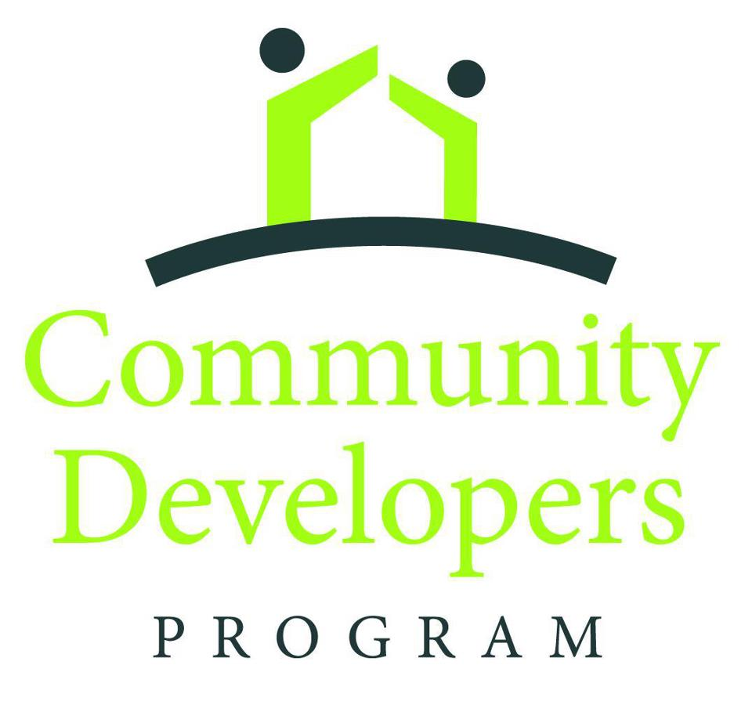

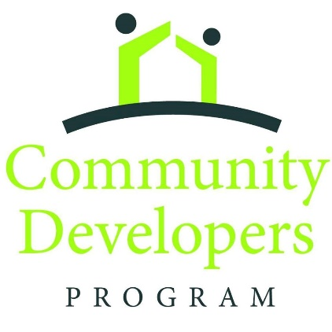
The Community Developers Program has a rich history of advancing the church’s capacity to be in mission through partnerships with the communities where they are located. A historically African American program, the Community Developers Program serves all racial/ethnic congregations and communities.

Sites within the Community Developers Program network address community concerns such as lack of affordable housing, health and wellness, school-age academic support, food insecurities, and children and youth development.

Partners in Ministry, located in Laurinburg, NC, focuses on three ministry areas in response to the needs of the local district. Partners in Ministry works in collaboration with local churches and community organizations in the areas of youth and children ministry, housing repair, and resource and referrals to external agencies.

Lincoln Memorial in Buffalo, NY forged a partnership with the Cold Springs neighborhood, adjacent to the church, to create the Sons of David/African Warriors program. The Sons of David program provided academic tutoring, afterschool basketball opportunities, and mentoring to African American males between the ages of 12-18. As a result of the program, program participants experienced an increase in reading and math achievement levels, as well as an improvement in overall grades.

In 2019, Emory Beacon of Light, located in Washington, DC, opened the Beacon Center. The Beacon Center is providing 99 affordable housing units to the community. Within the Beacon Center are spaces for learning, as well as health and wellness. In the future, the Beach Center plans to open a restaurant and employ individuals returning to the community from incarceration.

This quadrennium, the Community Developers Program has awarded over 30 grants, totaling over $500,000. The grants have supported the salaries of community developers, various site program expansions, site resources, and training opportunities for CDP site staff and boards. It is our prayer the Community Developers Program will continue to expand to continue to make an impact throughout the United States.

Dana Lyles, PhD
Director, US Office on Multiethnic Ministries
General Board of Global Ministries

COMMUNITY DEVELOPERS PROGRAM NETWORK

- General Information –

The Community Developers Program (CDP) is a network of racial-ethnic congregations and communities throughout the United States committed to advancing the church’s capacity to be in mission in partnership with the communities where they are located. Work includes advocacy, economic development, youth organizing, addressing local needs, creating an awareness of national and international causes and effects.

The Community Developers Program is administered through the General Board of Global Ministries. Other General Board of Global Ministries staff and consultants assist by conducting site visits, carrying out training responsibilities, and in developing and planning strategies for addressing global and national issues.

Seed grants ($10,000) are awarded to local racial-ethnic congregations to discern the willingness and ability to become a Community Developers Program site. Seed grants can be used for the following, but not limited to:

- Community mapping
- Congregation and community engagement
- Community assessment
- Creating and expanding community partnerships
- Recruiting volunteers to work towards making systemic changes
- Asset based community development
- Advocacy and social justice.

- Instructions -

1. Answer all questions as completely as possible in the space provided. DO NOT write “SEE ATTACHED” in the place of an answer.

2. You may attach additional information to the completed application form.

3. Complete the Budget Summary and include the anticipated contribution that the Annual Conference will make to the proposed ministry. It is expected that the congregation will contribute at least 10% of the requested amount.

4. UApproval by the Administrative body of the sponsoring United Methodist Church must be U Uindicated by the appropriate signatures.

COMMUNITY DEVELOPERS PROGRAM NETWORK
GENERAL BOARD OF GLOBAL MINISTRIES
THE UNITED METHODIST CHURCH

PROJECT APPLICATION

I. PROJECT IDENTIFICATION

A. Sponsoring United Methodist Church Information
Name ___________________________________________________________
Mailing Address ___________________________________________________
City / State / Zip ___________________________________________________
Primary Phone _________________ Secondary Phone ___________________
Fax __________________ Email _____________________________________
Website: _________________________________________________________
Racial Ethnic Group ________________________________________________

B. Contact Person
Name _____________________________________ Title __________________
Mailing Address ___________________________________________________
City / State / Zip ___________________________________________________
Primary Phone _________________ Secondary Phone ___________________
Fax __________________ Email _____________________________________

C. Conference Representative
Bishop’s Name (Printed)_____________________________________________
Bishop’s Signature _________________________________________________
Annual Conference ________________________________________________

D. District Representative
District Superintendent Name (Printed) _________________________________
District Superintendent Signature _____________________________________
District __________________________________________________________

E. Describe the sponsoring church including membership, racial ethnic composition, age levels and existing programs.

II. PROJECT DESCRIPTION

A. Provide a detailed, but concise description of this project and how it relates to the goals of Community Development. Include its innovative aspects as well as expected outcomes.

B. Identify the community issues that make this project necessary.

C. What are the long range and short-range goals? Include timelines for achieving goals.

D. Please describe how the program will be implemented.

E. What is the expected outcome?

G. How will this program sustain beyond the initial seed grant funding?

H. What is the process of evaluation of this local program?

I. What is the target population by age, race and gender? How many people will be served (Men? Women? Children?)

III. RELATIONSHIPS

A. How will this local program relate to the sponsoring church?

B. How will this local program relate to secular and ecumenical organizations and agencies?

C. How will this local program relate to the District and Annual Conference where it is located?

D. What is the involvement of the community with the sponsoring church?

E. How will this local program relate to General Conference’s Four areas of Focus?
Check all that apply and provide explanation about each involvement.

_____Global Health Initiative

_____Ministry with the Poor

_____Leadership development

_____Church growth and development

F. Please submit church’s child protection/Safe Sanctuaries policy

IV. BUDGET SUMMARY

Applicants must contribute at least 10% to the income of the requested amount.

Expenses | USD $
TOTAL Expenses
Income
TOTAL Income
V. OFFICIAL AUTHORIZED SIGNATURES

A. Person Completing Application
Name ___________________________________ Title ___________________
Signature ________________________________ Date ___________________

B. Sponsoring United Methodist Church
Name of Pastor ___________________________ Title ___________________
Signature ________________________________ Date ___________________

C. Sponsoring United Methodist Church
SPRC Chair Name _________________________________________________
Signature ________________________________ Date ___________________

D. District Superintendent
Name ___________________________________________________________
Signature ________________________________ Date ___________________

Consultation with Director of Connectional Ministries and Bishop: My signature below confirms that I have reviewed the application and / or that I am otherwise knowledgeable about the project and its current proposal before the General Board of Global Ministries. Furthermore, I have attached to this application any comments I wish to have considered as this proposal is evaluated for possible finding approval through the Community Developers Program of the General Board of Global Ministries (See Paragraph 263 of the 2016 Book of Discipline).

E. Annual Conference - Director of Connectional Ministries or Equivalent
Name __________________________________________________________
Signature ________________________________ Date ___________________

F. Annual Conference – Bishop
Name __________________________________________________________
Signature ________________________________ Date ___________________

All Completed applications are to be emailed to:

Dana Lyles, PhD – Director
Email: 3dlyles@umcmission.orgU30T
Multiethnic Ministries Unit
General Board of Global Ministries
458 Ponce de Leon Ave, NE
Atlanta, GA 30309
(T) 404.460.7393

